Sony Ericsson C902 disassembly

If you require a new screen, phone cover and screwdrivers, they can be purchased here: http://www.formymobile.co.uk/proddetail.php?prod=c902lcd&PARTNER=dismantle
Tools required: Torx 6 screwdriver, Phillips screwdriver
- Remove your back cover, battery, sim and memory card
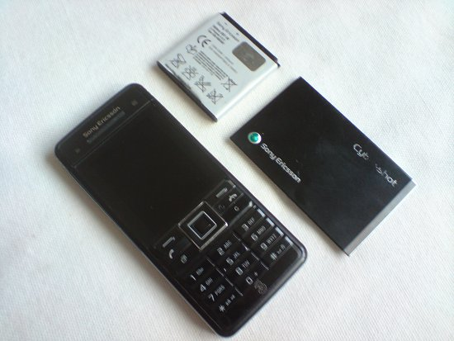
- Slide the top part of the phone up and peel back the sticker shown in the picture below. Do this on both sides of the phone. You may need something with a thin, sharp, metal point to peel the sticker back with.
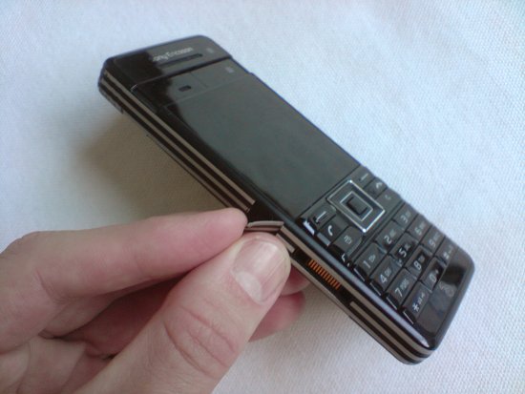
- The stickers should now be removed, like below. Now remove the two screws you can see.
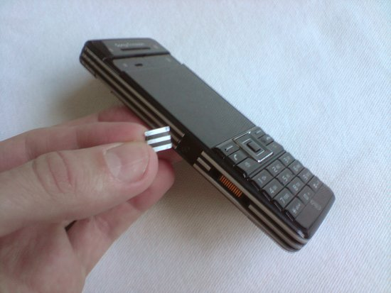
- Remove the sticker at the bottom of the phone, indicated by the screwdriver in the picture below.
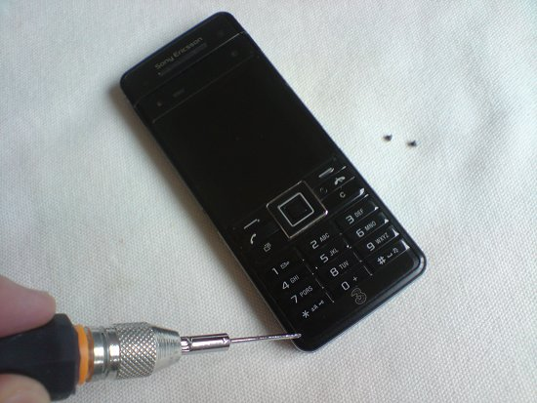
- With the sticker removed you'll have access to two more screws. Remove these.
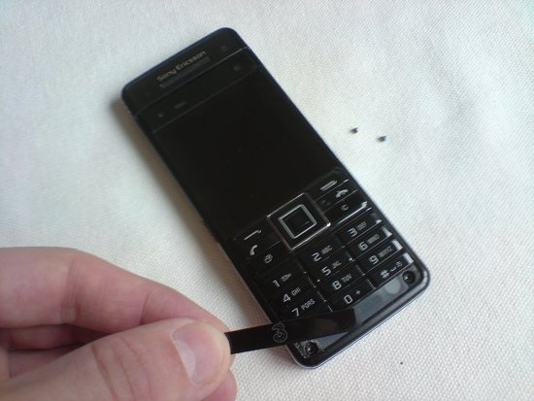
- You can now start to remove the metal battery compartment. Just unclip it at the bottom first, like below.
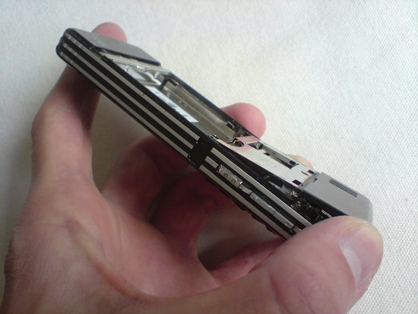
- Wedge the end of your Phillips head screwdriver behind the metal clips on each side of the phone to release them.
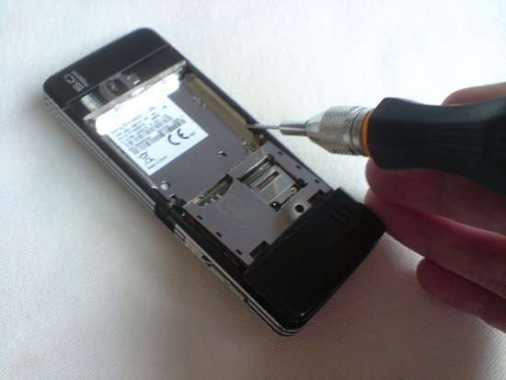
- Your phone should now look like below.
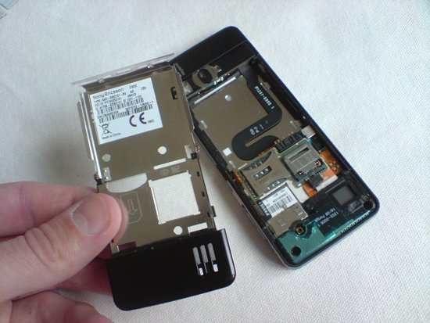
- You now need to detach a ribbon connecter, indicated by the screwdriver below. It attaches like a plug and socket. Simply lift it up to unplug it.
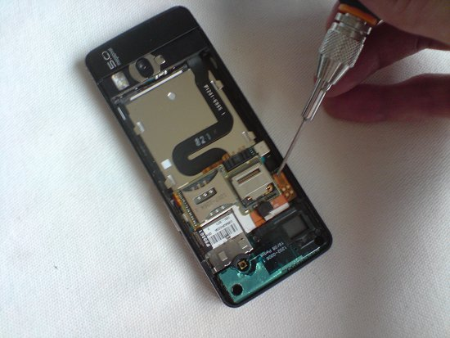
- You can now lift this part from your phone.
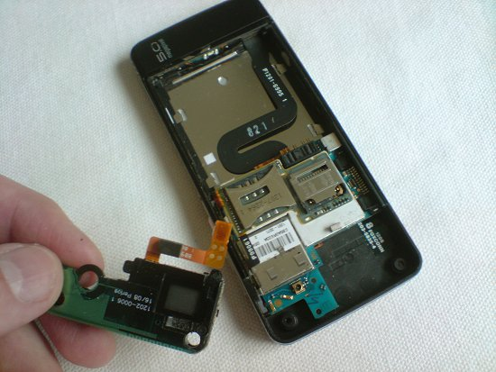
- Lift the printed circuit board from left to right. Three ribbons need disconnecting (in the picture below, the connector circled in green has already been disconnected from its ribbon cable). The green circled connector attaches like a plug and socket, as does the red circled ribbon/connector. The blue circled ribbon/connector slides out. Just pull it away from the connector and it should slide out.
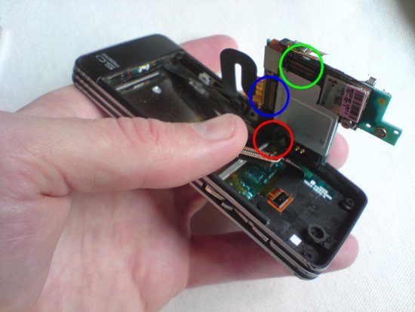
- Your phone should now look like below. The red circled ribbon/connector needs disconnecting. Again, it slides out. The four circled metal clips hold the LCD in place firmly. Bend these back
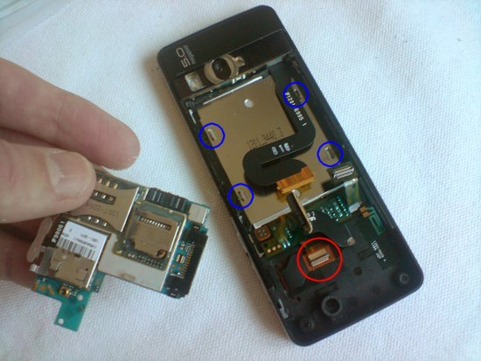
- Now remove the keypad. It will peel away from the phone with a little force.
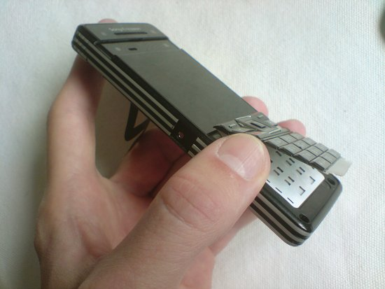
- You should now have the keypad removed.
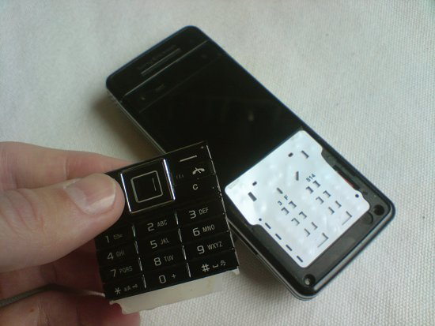
- Now peel the keypad membrane from left to right. There is a ribbon on the right hand side which will be torn if you do this any other way, so be careful.
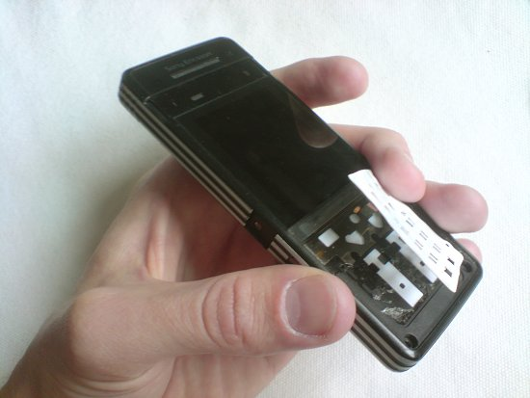
- Starting where the arrow indicates below, lift the LCD away from the phone.
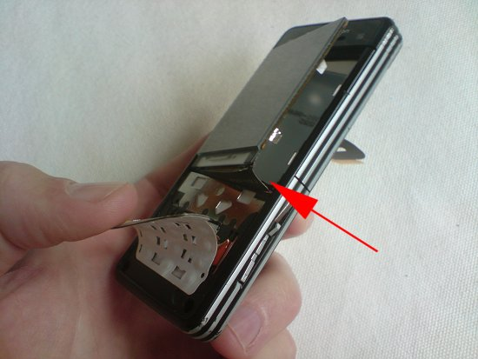
- You should now have the LCD removed. Lastly, remove the strip of lights that surround the LCD. They're stuck down with double sided tape and you'll need to stick these to the new LCD. Reverse the whole procedure for reassembly
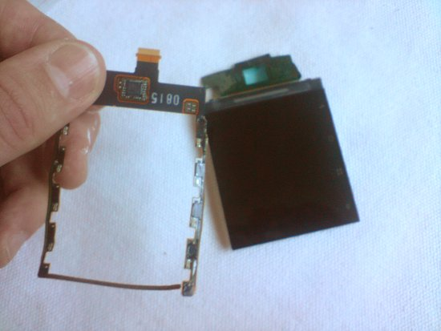
If you have any questions about Sony Ericsson C902 disassembly, email rob.lee@formymobile.co.uk. The official service manual for this phone may also help you with further Sony Ericsson C902 disassembly. Click here for details

