SETOOL Operation Manual

SETOOL is developed by Mr. the_laser and it's functions are:
(1) Read firmware from SE phones, such as AVR, ARM and GDFS. For example, you can backup and restore full GDFS.
(2) Read AVR , ARM & GDFS and convert it to DIV (*.sbn) and Twister (*.bis) format, so that you can share latest firmwares with your friends
(3) Write AVR, ARM and GDFS directly to your phone.

Supported Phones
R520/T39/T68/T300/T310/T230/T610/T630/Z600

Tools Needed
(1) Terminator Dongle
(2) SETOOL (Credits to Mr. the_laser)

Operations
(1) Download the SETOOL
(2) Unzip it to a folder say "setool" for example! You must use short folder name
(3) You will get 4 files after unzip
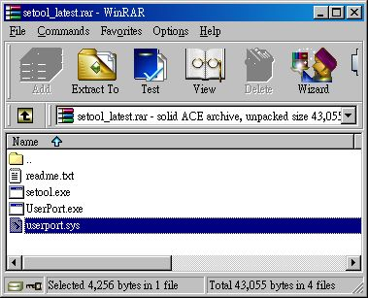
(4) Unless you are running Win98, otherwise you will need to copy "userport.sys" to "C:\Winodws\System32\Drivers"
(5) Double-click "UserPort.exe" and press "Start". Than Exit.
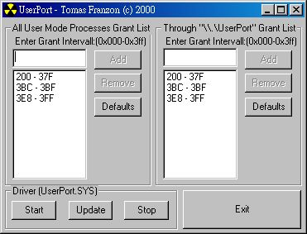
(6) Start "Command Promopt" in your Windows
(7) Follow the "readme.txt"

Operation Examples
Before we get start, we must have basic idea of what is the firmware address located. The following table will be a quick reference:
Phone Model | FULL AVR*  (begin-length) | AVR  (begin-length) | ARM  (begin-length) | GDFS  (begin-length)
R520/T39 | 00800000 - 00400000 | 00800000 - 00370000 | 01000000 - 00200000 | 00B70000 - 00080000
T300/T310/T68 | 00800000 - 00800000 | 00800000 - 00580000 | 01000000 - 00200000 | 00D80000 - 00270000
T610/T630/Z600 | - | 00800000 - 00700000 | 01000000 - 00300000 | 00400000 - 00400000

* FULL AVR = AVR + GDFS

(1) GDFS Backup and Restore
All phonebooks , personal settings, games, themes and phone are stored in the GDFS area of the firmware. After a Master Reset, you will lose everthing. Using SETOOL, you can makeFULL backup of the GDFS area and restore it.
a. GDFS Backup:
i) Connection the Terminator Dongle and your phone. Start the "Command Promopt" in Windows.
ii) Take T610/T630 as a an example. The GDFS for these phones are starting from 00400000, with length 00400000, So, you need to type: "setool /0 /b$400000 /l$400000"
iii) Press ENTER to start and it will take 10 to 20 minutes to complete the GDFS backup
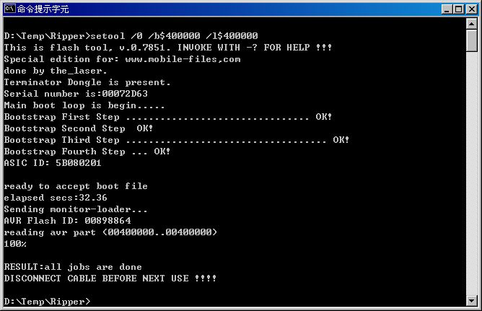
(iv) When the process is completed, you will get a file named "avr00400000..00400000.bin". This is your GDFS backup files in .bin format

b. GDFS Restore
i) Connection the Terminator Dongle and your phone. Start the "Command Promopt" in Windows.
ii) Type "setool /2 /gYOURFILENNAME.bin". For example "setool /2 /gavr00400000..00400000.bin" (Be reminded, there a "g" before the file name)
iii) Restore will take 10 - 15 minutes
iv) You may also retore your GDFS to other phones with same model (e.g T610 -> T610 or T630 -> T630), but after the restore process you have to run DIV and "Rebuild SP Area Using OTP IMEI" to solve the 4-locks
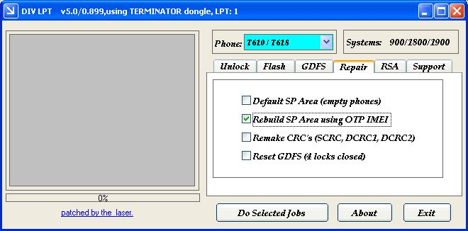

(2) Read AVR and ARM
You may read AVR and ARM with SETOOL. For example, reading AVR & ARM in T610/T630 is:
a. Read AVR: "setool /0 /b$800000 /l$700000"
b. Read ARM: "setool /1 /B$01000000 /L$300000 /a"
You may also use SETOOL to write the AVR and ARM to other phones:
a. Write AVR: "setool /5 /b$800000 /l$700000 /gYOURFILENAME" (be reminded that there is a "g" before ytour filename)
For example: "setool /5 /b$800000 /l$700000 /gavr00800000..00700000.bin"
b. Write ARM: "setool /4 /B$01000000 /L$300000 /gYOURFILENAME" (be reminded that there is a "g" before ytour filename)
For example: "setool /4 /B$01000000 /L$300000 /garm01000000..00300000.bin" (be reminded that there is a "g" before ytour filename)

(3) Read AVR & ARM and convert it to DIV format
a. Convert AVR to DIV format
Read AVR with method mentioned above. Save it to a folder.
1. Use Hex Workshop Hex Editor to open the file, For example, "avr00800000..00800000.bin"
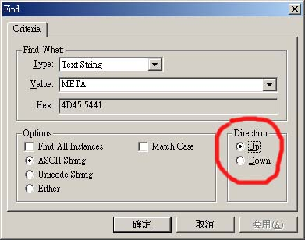
2. Go to the END of this file, than use SEARCH function in Hex Workshp to find a Text String named "META"! You have to search from the end of the file and search upward. In other words, you are looking for the first "META" from the end upward.
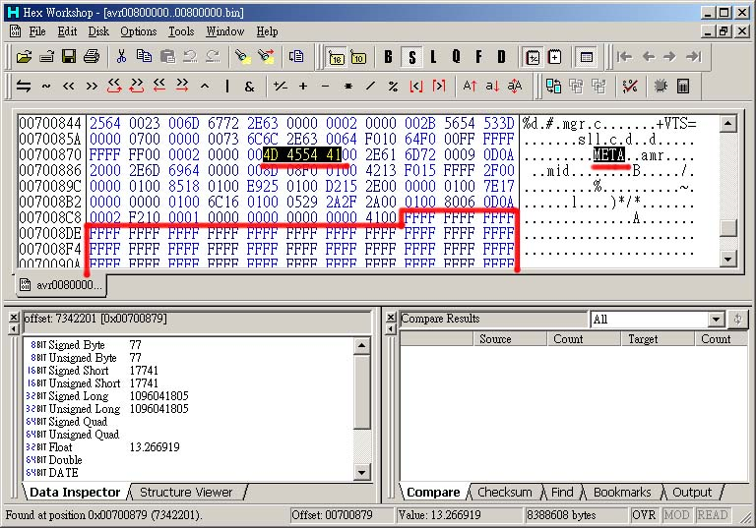
3. When you find the "META", delete all "FFFF" and the rest of file afterward.
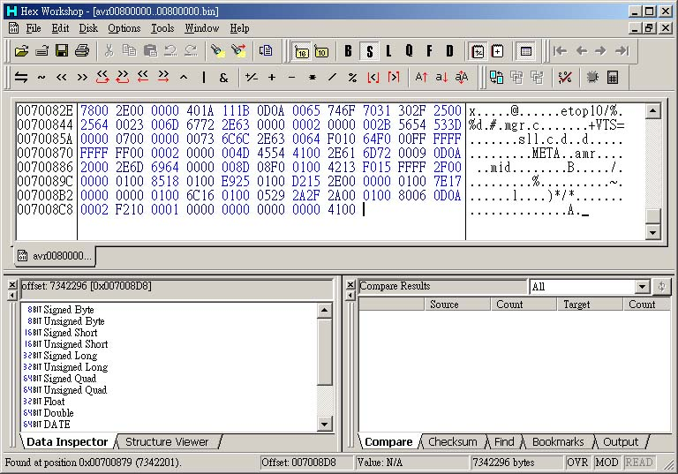
4. You are expected to get a result like above! Save the file and use bin2sbnl convertor (credits to Mr. SFlood) to convert it to flash files for DIV format.
5. Start Command Prompt and type "bin2sbnl YOURFILENAME", for example "bin2sbnl avr00800000..00800000.bin"
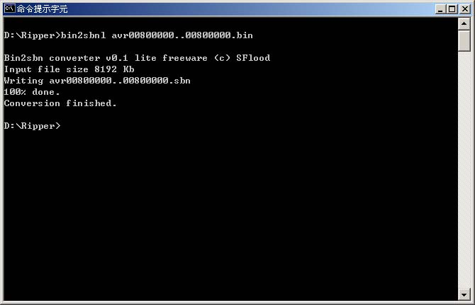
6. When the conversion is completed, you will get a file named "avr00800000..00800000.sbn". This is the AVR flash for DIV format
b. Read ARM and convert it to DIV modem format
1. 1. Use Hex Workshop Hex Editor to open the file, For example, "arm01000000..00400000.bin"
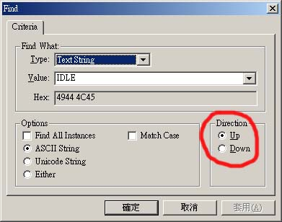
2. Go to the END of this file, than use SEARCH function in Hex Workshp to find a Text String named "IDLE"! You have to search from the end of the file and search upward. In other words, you are looking for the first "IDLE" from the end upward.
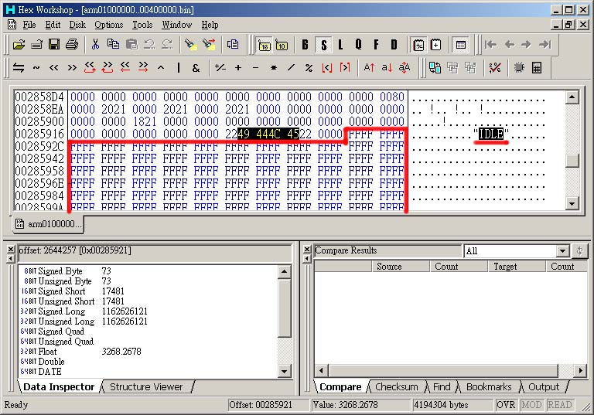
3. When you find the "IDLE", delete all "FFFF" and the rest of file afterward.
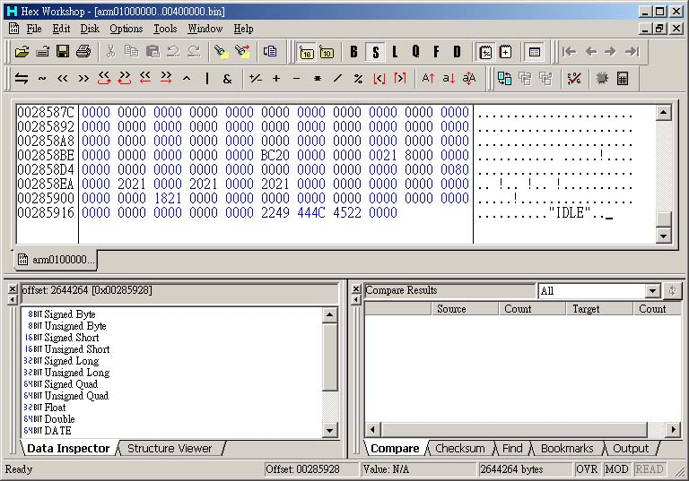
4. You are expected to get a result like above! Save the file and use bin2arm convertor (credits to Mr. SFlood) to convert it to modem flash files for DIV format.
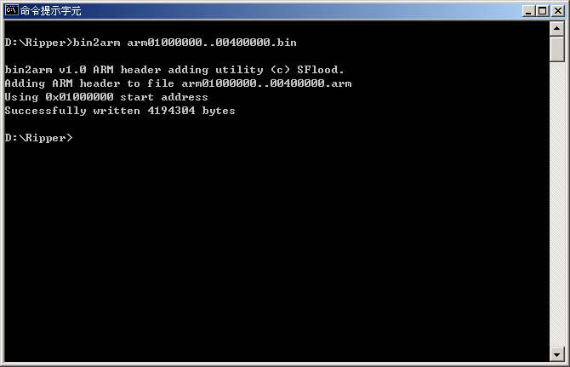
5. Start Command Prompt and type "bin2arm YOURFILENAME", for example "bin2arm arm01000000..00400000.bin"
6. When the conversion is completed, you will get a file named "arm01000000..00400000.arm"! This is the modem flash files for DIV format.

