CYTOWIN
Windows Analysis software
for
Flow cytometric data

version 4.3

November 2004

by D.Vaulot

CNRS et Université Pierre et Marie Curie
Station Biologique, BP 74
29682 Roscoff Cx, France
Tel: (33) 98 29 23 23
Fax: (33) 98 29 23 24
e-mail: Vaulot@sb-roscoff.fr

CYTOWIN is distributed free of charge
for academic use only.
Please include proper reference if it is used for a publication.
The author would welcome reprints of papers that make use of the program. Users are also kindly requested to communicate bugs they find.
Table of contents
Foreword
Citation
Hardware Requirements
Language
Revisions
I. Getting started
Software Installation
Running the program
In trouble ?
II. Running CYTOWIN
File format supported
Limitations
MENUS
FILES
CONFIGURATION
ANALYSIS
UTILITIES
Appendix 1 - Lin/log calibration of adcs
Appendix 2 - Software notes

Foreword
CYTOWIN (an evolution of CYTOPC) is a Windows program designed to analyse flow cytometer data list mode data. It is primarily meant for analyzing data stored following the Flow Cytometry Standard (FCS 1.0 and 2.0). See Chapter II for the file format that are currently supported.

CYTOWIN has been written by D. Vaulot from CNRS, Station Biologique, 29680 Roscoff FRANCE, with help from Jeff Dusenberry (MIT, Cambridge Mass USA) for bitmaps.

Citation
If you use CYTOWIN for data published in peer-reviewed papers please include the following citation:
Vaulot, D. 1989. CYTOPC: Processing software for flow cytometric data. Signal and Noise 2:8.

Hardware Requirements
- IBM-PC or compatible with hard disk.
- Windows 3.1 (not tested on Windows 95)
- As much memory as you can since all cells are held in Memory now.
- Mathematical coprocessor 8087 (I can supply a version that does not requires it).

Language
CYTOWIN is written in Pascal and compiled with DELPHI version 1.0 (Borland, Scotts Valley CA). One subroutine library (TPStrings) is from Turbo Professionnal (Turbo Power, Scotts Valley CA USA) and one (VLArrays) public domain from Robert Warren.

Major revisions
- 4.0 (March 1995): version for Turbo Pascal for Windows 1.5
- 4.1 (Dec 1995): version for DELPHI
- 4.2 (Nov 2003): Include FACSaria
- 4.31 (Nov 2003): For new version of FACSaria software

What’s new

Version 4.31 (nov 2004)
- New Aria software requires files for CytoWin to be saved as FCS 2.0 in 1024 channels in log mode (cannot read native FACSAria files or FCS 3.0).

Version 4.2 (nov 2003)
- CytoWin can now read FACSAria files saved as FCS3.0 in 1024 channels (cannot read native FACSAria files).
- Maximum number of parameters extended to 12 including Time.
- Configuration file format has changed since the previous version (4.1). Therefore they cannot be directly read. Instead use the Menu Item “Import Configuration File 4.1 or older”.

I. Getting started

Software Installation
- Get CYTOWIN.ZIP from the Roscoff web site
- Create a directory called C:\CYTOWIN.
- Copy CYTOWINZ.ZIP to the new directory C:\CYTOWIN.
- Extract the following files to the directory C:\CYTOWIN.

CYTOWIN.EXE Cytowin program
CYTOWIN.CFW Cytowin configuration file
FACSNET.CFW Cytowin configuration file
FACSNET. FACS list mode example
MDADSLST. EPICS list mode example
MDADS2P. EPICS cytogram example
CYTOWIN.DOC Word for Windows document
- Create a New Program Item with CYTOWIN.EXE in one of your Windows Group.

Running the program
- If you do not have much memory, remove as many Windows applications as possible from Memory since CYTOWIN puts all cells in Memory.
- Click on CYTOWIN icon....
- You can get a feeling for what CYTOWIN can do by loading the configuration FACSNET.CFW and then analyzing the FACSNET data file.

In trouble ?
If you have carefully read the manual and set up the different hardware options right, everything should go smoothly. However since nobody is perfect here are some common mistakes and problems.
After selecting the files correctly, the program does not want to process them. This is most likely a memory problem. Shut down other programs running under Windows.
Some files work, some don't. This might happen if you are processing files from different origin, such as ASCII and Easy files, at the same time. Since settings are different between these files you cannot process them together. Also CYTOWIN does not handle mixed modes on the FACScan (e.g. mixtures of 256 and 1024 parameters in the same list mode.
No printer output. You probably did not select a connected printer. Use menu entry Files/Printer Setup.
Impossible to get the cells in the window you defined. Go to the Configuration /Statistics menu and reset all windows. Then draw again your windows.

II. Running CYTOWIN

File format supported
- ASCII generic files (one parameter histograms with one value per line)
- Coulter EPICS and PROFILE files transferred to PC with EASY2 software (FCS 1.0 format, one parameter histograms 256 channels, two parameter cytograms 64x64, listmodes)
- Becton Dickinson FACScan and FACSort (listmodes only) acquired with HP computer and transferred to PC with FACSnet software (FCS 1.0 format) or acquired with Mac FACStation (FCS 1.0 or FCS 2.0 format).
- Becton Dickinson FACSAria (listmodes only) saved in FCS 2.0 format on 1024 channels in log mode (will not work with higher resolution.
- Cytomation CICERO files (FCS 2.0 format, one parameter histograms up to 1024 channels, two parameter cytograms up to 128x128, listmodes).
- Coulter ELITE (listmodes only). Only 1024 channel resolution files have been tested.

Limitations
- Maximum number of parameters (=ADCs): 12. CICERO and FACSAria files have Time stored as the last parameter, so these files are limited to 11 parameters besides time.
- Mixed modes are not allowed (e.g. on FACScan, mixtures of 1024 and 256 channels parameters)
- Maximum number of plots per screen: 100 (10x10).
- Maximum number of cytograms per list mode file: 9
- CICERO one parameter histograms: channels with more than 64 K events are truncated.

MENUS
The main menu permits access to all the settings and functions of CYTOWIN.

FILES

Get Configuration
You are provided with a list of configuration files. CYTOWIN configurations have extension *.CFW. These files contain most of the information needed for file format and windows etc.. The file must be in the format used by CytoWin 4.2 or a more recent version.

Import Configuration 4.1 and older
Same as previous item except that it allows to import older configuration files from CytoWin version 4.1 and older.

Save Configuration
You are provided with the name of the current configuration file. If you want to save the current configuration under a different name then modify it. The extension .CFW is always added to the file. The file is saved under format 4.2.

Get Data Files
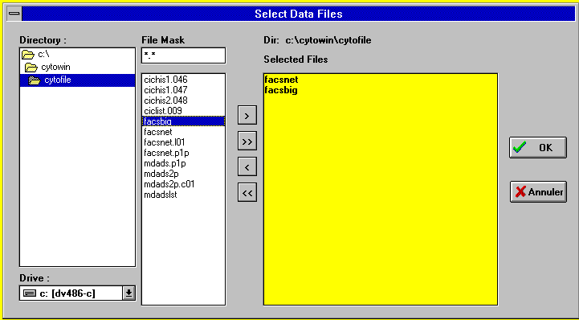
Use left part of screen to change drive, path and file mask. The list is automatically updated. The yellow panel contains the file that have been selected. The buttons allow you to select either one file, all files and conversely to deselect either one or all files.

Printer Setup
CYTOWIN makes use of a printer to record statistical results and to provide screen hard copies. Us this entry to select the correct printer.

Exit
When you exit you are asked whether you want to save the current configuration file (Yes) or not to save it (No) or whether you want to go back to CytoWin (Cancel)

CONFIGURATION

Data Files

Input Files
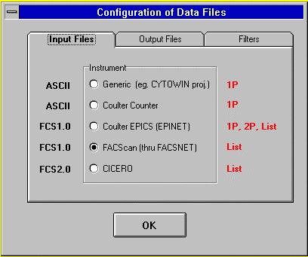
Instrument (IMPORTANT) : Tells from which machine the data are coming from. Generic corresponds to simple ASCII files for one parameter histograms. Coulter Counter corresponds to 100 channels ChannelAnalyzer distributions obtained from the Coulter Counter. Coulter EPICS corresponds to Coulter EPICS and Profile data transferred by EPINET, M86PAS or PROPAS. FACScan corresponds to Becton Dickinson FCS 1.0 format acquired with HP transfered though FACSnet or FCS 2.0 acquired with Mac FACSstation. CICERO corresponds to files generated with CYCLOPS software from CYTOMATION inc. Coulter Elite corresponds List modes stored under FCS 2.0 format.

Output Files (only for converting data)
This defines the format of the files that are converted by the Convert Utility (see below).
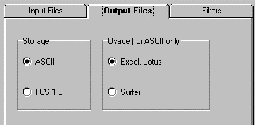
Storage: (Only for List mode) List mode files can filtered (see below) and then stored either as FCS 1.0 (binary format) or ASCII (Text mode).
Usage of converted file : (Only for 2P cytograms and ASCII) Cytograms can be converted to a plain ASCII text file for use with Excel or Lotus or to a specially formatted file which can be then imported directly in the SURFER program for contouring and 3-D plots.

Filters (only for converting data)
For 2P cytograms filtering consists in setting to zero all elevations which are below a critical threshold. For list mode files, you must choose an ADC and then only the cells which will have a value for this ADC larger than the threshold will be written to the output file.
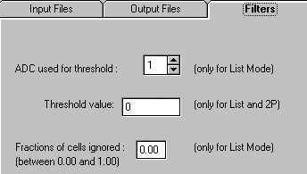
ADC used to threshold list files : (Only for list files) For example if you want to output only the cells which have a signal on ADC3 falling beyond channel 10 you should enter 3 here.
Threshold : For the previous example you should enter 10 here.
Fraction of cells ignored (only for list mode ) : This permits to discard a fixed fraction of the cells at the beginning of list file. This is useful in some cases when some of the parameters are drifting at the beginning of a run (e.g. DNA).

Flow cytometer ADCs
This option permits to change the set up and calibration factors either for the parameters (ADCs) measured by the flow cytometer. The maximum number of parameters for the present version of CYTOWIN is set to 9. Beware that CICERO files always contain time as the last parameter.
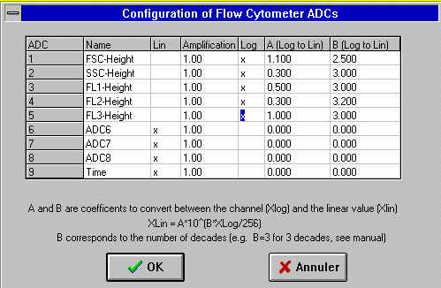

MDADS ADC Names : For each ADC, you can enter the corresponding parameter name (no more than 6 characters). For EPICS files, these names are used inbstead of those transferred from the MDADS. For FACS and CICERO files, the names defined on the flow cytometer are used (not the one defined in CYTOWIN).
MDADS ADC Scale : For each ADC you can specify whether the input signal is converted on a linear or a log scale. To switch between log and lin scale double click on the corresponding column.
- If the input signal is on a linear scale you can define the amplification factor you used. All results are then converted to an amplification of 1.
- If the input signal is on a log scale you have to define 2 parameters A and B which permit to go from the log scale to the linear scale. The conversion formula is as follows:
XLin = A*10B*XLog/Total Number of Channels
The converted XLin corresponds to the linear signal recorded with the amplification set to 1 on 1 to 256 channel scale. B corresponds to the number of logarithmic decades. For example, B = 3 corresponds to a 3 decade logarithmic scale. A and B are log-amplifiers dependent and must be carefully determined for each of your amplifiers (see Appendix).
Important remark. In list mode it is assumed that there is no gap in the ADCs which are recorded. For example for EPICS files, if on the MDADS you have the following configuration:
ADC 1,3,4,5,6 on
ADC 2 off
then CYTOPC will assume that:
ADC 1,2,3,4,5 on
ADC 6 off
therefore:
ADC 1 of MDADS corresponds to ADC 1 of CYTOPC
ADC 3 of MDADS corresponds to ADC 2 of CYTOPC
ADC 4 of MDADS corresponds to ADC 3 of CYTOPC
ADC 5 of MDADS corresponds to ADC 4 of CYTOPC
ADC 6 of MDADS corresponds to ADC 5 of CYTOPC
MDADS ADC scales, calibration factors and names must be set accordingly.

Screen Plots
This option allows to define how the screen is organized.
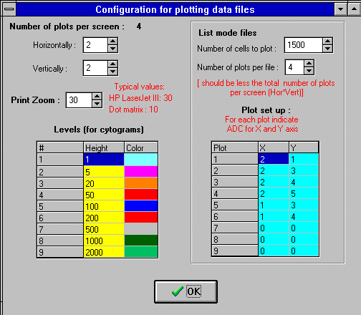

Number of plots per screen. This gives the total number of plots displayed in a single screen. Horizontally : # of plots in the X direction (max=10). Vertically: # of plots in the Y direction (max=10). Use typical numbers between 1 and 4 for each direction. The maximum number of plots per screen is 100.
Print Zoom. This factor is used when printing the graphics to the selected printer. Modify empirically as needed. A Print Zoom value of 30 gives nice results wich HP LaserJet III printers. If your output is too small, increase the value, and conversely. The value entered must be integer.
Levels : (Two parameter cytograms only) Change the height of each level (maximum = 9). The colors can be changed by Dble Clicking on the corresponding cell. Only scatter plots are possible (not contours as in the previous version of CYTOPC).
List modes. In list mode (see below), each cell is defined by the value recorded for each ADC (on a 1 to 256 scale). For each list mode file, CYTOWIN allows you to generate up to 9 two parameters plots (Number of Plots per File). For each plot you must select which ADC will correspond to the X and Y parameters (Plot set up). If no statistical window is active, then all cells are plotted in the same color (White by default).
Number of Cells per Plot : To save time only a limited number of cells are plotted on each graph. Usually from 1000 to 5000 cells are enough to be able to accurately define windows. The statistics however are computed on the total numbers of cells held in the file.
Number of Plots per File : (max = 9) Total number of plots to be generated for each list file. In contrast to CYTOPC, CYTOWIN requires that all plots for a given list mode file reside on the same screen. Therefore, the number of plots per file must be less than the total number of plots possible per screen (=horizontal*vertical). If you want to increase this number, you must first increase the number of possible plots per screen.
Plot set up : Permits to select which CYTOWIN ADCs are chosen as X and Y parameters for each plot. These are the CYTOWIN ADCs and not the original ADCs (see remark above).

Statistics
In order to identify subpopulations you must interactively define gates called by CYTOWIN statistics windows (see below Analysis Menu). Statistics windows are hypercubes/hyperbitmaps defined in the space of the ADC, e.g. a five-dimension space if 5 ADCs were recorded, by a combination of rectangular windows or polygonal bitmaps on two parameter cytograms. To each statistical window corresponds a given color and cells which will fall inside the window are colored accordingly. When all the predefined plots have been achieved the statistics inside each active window are computed. There are two types of windows: Bead windows are used for normalization, Cell windows contain the population of interest.
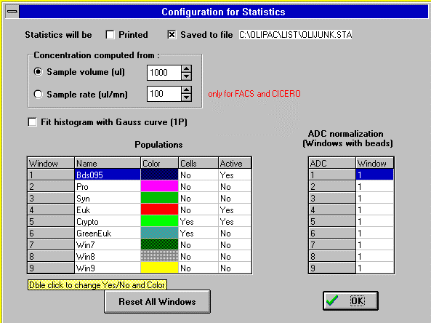
Statistics will be printed : Toggle ON if you want the results of the statiscal analysis to be sent to the printer (the printer must be set up from Windows Configuration panel).
Statistics will be saved to file : Toggle ON if you want the results of the statistical analysis to be sent to files. The default file name is given on the right. If you want to change the name double click on it. You will be prompted for a new name. You do not need to provide an extension. Two files will be created with extensions *.STA and *.NOR. These files will reside in the same directory than the data files and can be loaded into Excel (Tab delimited). If files with the same name already exist, the new statistics will be appended to the existing files.
- The first file (*.STA) contains raw statistical data. The format has been changed considerably from CYTOPC. Each line corresponds to one file. For each window and each parameter, the mean and CV are computed and given in a column.
- The second file (*.NOR) contains normalized statistical data in compacted format. For bead windows only the number of particles is given. For cell windows, the file provides the number of particles per unit volume (mL) computed either from the volume run or from the rate of passage and the time run, as well as the mean of each parameter normalized by the same parameter measured on a selected bead window. Windows that are not defined as cell windows and are not used for normalization
Concentrations computed from:
Sample volume : When running a fixed volume, enter this volume here (in μL, not mL; use only integer). The concentration of particles in each cell window will be given per volume unit (mL) in the .NOR file.
Sample rate : When running a fixed rate, enter this rate here (in μL/mn, not mL/mn; use only integer). This mode is only possible for FACS and CICERO files that record the duration of the acquisition (FACSort files from HP: Note that there is a bug in the LYSIS II program that may cause time to be underestimated by about 30 sec in some cases). The concentration of particles in each cell window will be given per volume unit (mL) in the .NOR file.
Fit histogram with Gauss curve (only 1P histograms): When the left part of a histogram merges with noise (e.g. for surface Prochlorococcus), this option allows to fit a gauss function to the histogram. The fitted histogram appears as a line. This extrapolation allows to better estimate both cell concentration and histogram mean. You must use a window that does not include any of the noise but that does include the histogram maximum (see below)! When the maximum lies in the noise, the fitting is impossible.
Statistics windows : For each window (population) you may provide a Name that will be used in the output files. Color can be changed by Double Clicking on the corresponding cell. Define each window as containing or not Cells by double clicking on the corresponding column. Define also by double clicking whether the window is Active or Inactive (statistics are only computed for active windows). In the example displayed above, we assume that you have 3 cell populations: Prochlorococcus in window 2, Synechococcus in window 3 and eucaryotes in window 4. Window 1 contains 0.95 μm beads.
Reset all windows : Sometimes it is wise to reset all windows to their default value (1..256), especially when doing list mode processing with new files.
ADC normalization: For each ADC you may specificy a window (called Bead window) which will be used as a reference for this ADC in file *.NOR. In the example displayed above, we assume that you have 0.95 μm beads in window 1 and that all parameters are normalized to these beads. However, this can be more sophisticated. For example if you have 0.95 micron non-fluorescing beads falling in window 1 and 10 microns fluorescing beads falling in window 2 you may normalize FALS and LS90 (e.g. ADC 1 and 2) to window 1 and Green and Red fluorescence (e.g ADC 3 and 4) to window 2. For a given ADC if you choose window 0, statistics in file *.NOR will not be normalized.

ANALYSIS
In order to begin processing you must press on .
After each file has been plotted a certain number of options are available for statistical analysis. Briefly it is possible to define a maximum of 9 windows in which the following statistics are computed :
- Mean
- CV (in %)
Statistical results are computed on a linear scale (after eventual tranformation from the initial logarithmic scale: see above Flow cytometer ADCs Menu). For EPICS, Elite, FACS and CICERO files, the last channel is adjusted to 256 irrespective of the initial scale (i.e. 64, 256, 1024 or more).
Rectangular windows and bitmaps are defined between 1 and the maximum number of channels (256 for 1 parameter and list modes and 64 for 2 parameter EPICS histograms). After resetting all windows (Configuration/Statistics) or in the absence of a configuration file, all windows are inactive and defined from channels 1 to 256. On a given cytogram, a statistics window can be defined by either a rectangular window or a polygonal bitmap. Bitmap vertexes are limited to 10. The number of bitmaps is limited to 9. Therefore, use only bitmaps when necessary. Most of the time, rectangular windows are sufficient.
To change window and bitmap boundaries use the  and  buttons. Rectangular windows and polygonal bitmaps are mutually exclusive: when you press and give the number of a statistical window for which a bitmap was already defined, the bitmap will be erased and conversely. When a window has been activated it remains in effect for all the subsequent files even after going back to the main menu. To activate or inactivate a previously defined window, use the  button. Once you have defined all your windows, you must use the  button to see the effect of these changes on the populations. Histograms and of a window population can be stored in ASCII form with the  button. Choose to go back to the main menu and to print the graphs.
will initiate the computation of the statistics and proceed to the next file on the list you selected.

All commands can invoked either by :
- a PopUp Menu obtained by clicking on the right mouse button
- short cut key strokes similar to CYTOPC ones
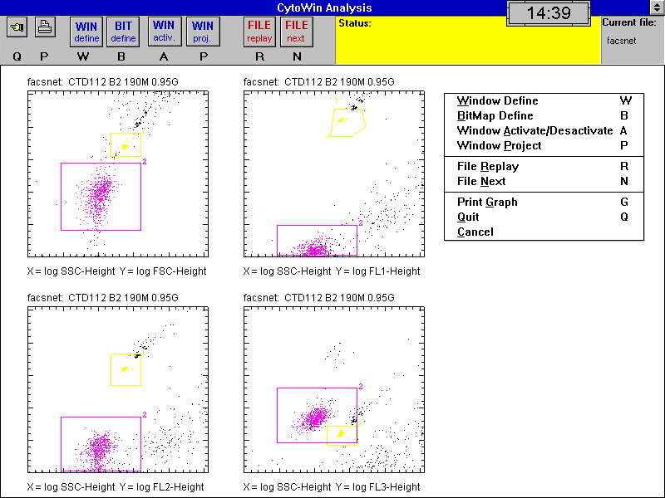
: (short cut = Q) Quit to return to the main menu computing the statistics of the current file and skipping the remaining files .
: (short cut = G) Print the graph as is. Make sure that you set up the printer correctly.
: (short cut = R) Replay the current file. Regenerate all the plots of the current file, taking into account the latest definition of the windows. This is useful once all the windows have been correctly defined.
: (short cut = N) Compute statistics of the active windows and go to next file.

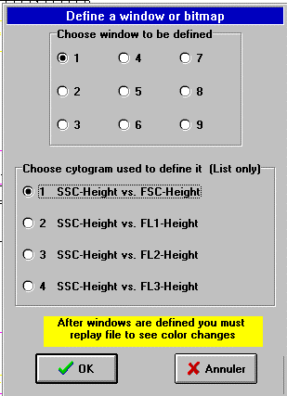
: (short cut = W) Change the limits of a rectangular window. The user is prompted for the Window number (between 1 and 9) and then for the Cytogram where to define the window. A cursor appears on the screen and the user must first click with the left button for the left bottom corner, then expand the window and click again for the right top corner of the window. !!! Make sure you draw the window on the plot you have selected. If not, your window will be set incorrectly.
: (short cut = B) (Only for 2P-cytograms) Change the limit of a bitmap. The user is prompted for the Window number (between 1 and 9) and then for the Cytogram where to define the window. Click on the left mouse button to define a vertex. Press on the right mouse button to close the bitmap.
: (short cut = A) Activate/Deasctivate a window so that statistics will be computed/not computed in this window. The user is prompted for the Window number (between 1 and 9)
: (short cut = P) (only for cytograms and list modes) Store one Projection per ADC of the data points lying within windows into files written in ASCII format. The user is prompted for the windows that are to be projected. Several windows can be projected at once. The projections for different Windows and ADCs are stored in subdirectories of the data directory. The fist letter of the file is changed to $ to avaoid erasing data files. If the data file is called DATA0001 then the projections of Window 1 onto ADC 1, ADC 2, ADC 3 are stored into files ..\WIN1\ADC1\DATA0001, ..\WIN1\ADC2\$ATA0001, ..\WIN1\ADC3\$ATA0001. Beware that several files with the same names now occur in different directories. The files can be renamed as necessary before transfer to the data directory.

UTILITIES

Convert Files
This module converts files according to the format that has been set in the Configuration/Output Files Menu.
Output File Name. The main part of the output file name is the same than that of the input file. The extension begins by an U for 1 parameter histograms, by a C for 2 parameters cytograms and by and L for list mode files. This letter is followed by a number which is unique to the file. Both input and output file names are sent to the printer. For surfer type files the extension is .GRD .
Example: if the input file name is DATA0001 or DATA0001.PRN and the file contains list mode data, the output file name will be DATA0001.L01 if no file with the same name exists and DATA0001.L02 if a file with extension L01 is already present.
Output File Content

Type | Output Choice | Format
1 parameter (256) | ASCII | 1 channel per line
2 parameters (64x64) | ASCII  LOTUS | 1 channel per line
2 parameters (64x64) | ASCII  Surfer | 8 channels per line
List | ASCII | 1 cell per line
List | Easy | FCS 1.0 format
Examples of output files
1 parameter
0 <-- Number of cells in channel # 1
0 <-- Number of cells in channel # 2
0 ...
1
2
4
.....
2 parameters (LOTUS)
1 1 0 ⇦ Number of cells in channel # 1,1
1 2 10 ⇦ Number of cells in channel # 1,2
1 3 25
1 4 20
..........
List mode
ADC1 ADC2 ADC3 ADC4
253 147 4 104 ⇦ cell number 1
253 133 5 104 ⇦ cell number 2
253 1 65 12 150
..........

Sample Information (FCS files only)
This module output the information held in the FCS file header to a TEXT file with column separated by Tabs for use with EXCEL or a data base program. This will only work for FACScan, FACSAria, Elite, EPICS and CICERO files. The file where information is stored will have an extension as *.FCS. The first time the file is created a header with the name of the column will be written.
The output is as follows.
FACScan files

Directory | File | Date | Time_  Begin | Description | Laser_  Power | Laser_  Current | Sample_  Pressure | N_of_cells | Duration | N_ADC | Trigger | ADC1_  Name | ADC1_Voltage
C:\OLI112 | P112001 | 11/26/1994 | 05:55 | CTD112 B2 190M 0.95G | 15.05 | 3.56 | 5.58 | 6238 | 4 | 5 | FL3-H,,0 | FSC-Height | E02
C:\OLI112 | P112002 | 11/26/1994 | 06:00 | CTD112 B3 170M 0.95G | 15 | 3.34 | 5.58 | 13406 | 4 | 5 | FL3-H,,0 | FSC-Height | E02
FCS keyword |  |  |  | SAMPLE ID
CICERO files

Directory | File | Date | Time_Begin | Operator | Project | Experiment | SampleName | Description | N_of_cells | Duration | N_ADC
c:\cytowin\cytofile | ciclist.009 | 02-Oct-95 | 11:21 | hector |  | Lisa Campbell | 17 07 1 | 100M | 64230 | 1.95 | 7
c:\cytowin\cytofile | cicdomi.005 | 04 Dec 1995 | 13:50 | dominique |  | DM | medipela | 03.8 t0 hoechst | 50000 | 4.53 | 6
FCS keyword |  |  |  | $OP | $PROJ | $EXP | $CELLS | $SRC

Appendix 1 - Lin/log calibration of adcs

The A and B coefficients are amplifier specific. in order to compute them for your own system, follow these steps for each amplifier :
1 - Put linear signal on ADC1 (amplification set to 1).
2 - Put log signal on ADC2.
3 - Create a protocol where ADC1 vs ADC2 (64x64) is collected.
4 - Run some beads and vary the amplifier high voltage so that you get a continuous trace on the ADC1 vs ADC2 histogram. This trace is a plot of the linear channel (X) vs the log (Y) channel.
5 - Since A coefficient is defined for 256 channels and B does not depend on the number of channels you should have (cytopc manual p.11) :
X = (A/4)*10(Y*B/64)
i.e.
log X = (B/64)*Y + log (A/4)
6 - Therefore, you can obtain both A and B by computing the values of several couples of (X,Y) on the curve and making a linear regression between log X and Y. typical values with an EPICS 541 are A = 0.3 and B = 3.0 for the PMT amplifier and A = 1 and B = 2.5 for the FALS amplifier.

+ This calibration could also be done by collecting the log and the linear signals in list mode and regressing the two signals.

Appendix 2 - Software notes

The program CYTOWIN is written in Pascal compiled with DELPHI version 1.0.

The program is organized into the following modules:
- CYTOWIN.PAS is the main calling program.
- CTYPE.PAS contains all type, constant and variable declarations which are used in the other modules and are global to the program. New declarations MUST be included in this module.
- CFILE.PAS manages most of file reading and writing.
- GRAF.PAS manages all low level graphics routines. It relies on the Delphi implementation of Windows GDI.
- CPLOT.PAS manages all the higher level graphics. It is device indeendant.
- CSTAT.PAS manages all the computationnal procedures which are specific to the statistical processing of histograms and cytograms as well as the statistical output.
- The following forms are also used:
- Cfrmfile : Choose files
- Cfrmdata : Data File types
- Cfrmadc : Configuration of ADCs
- Cfrmcplo : Configuration of Plots
- Cfrmstat : Configuration of Statistics,
- Cfrmabou: About Box;
- Cfrmplot : Main plotting window
- Cfrmwin2 : Define Windows / BitMaps
- Cfrmwin3 : Define Active windows
- Cfrmwin4 : Define Windows to project

This does not work under Windows XP. Use instead Windows Printer Panel to select a default Printer.
Does not work under Windows XP. Will always print to the default printer.

