Driver Installation for Windows 98 SE

Driver Installation Guide Format

New Driver Installation for Windows 98 SE: Use these instructions if you have just installed an USB 2.0 card into your system. Remember that the first time you start your system after installing a card, it may take longer due to the fact that the operating system is locating and installing drivers for the card.

Verifying Driver Installation for Windows 98 SE: Use these instructions to verify successful driver installation on your system.

New Driver Installation for Windows 98 SE

1 Windows will install the first OHCI (USB 1.1) controller. When the Add New Hardware Wizard opens, click Next.

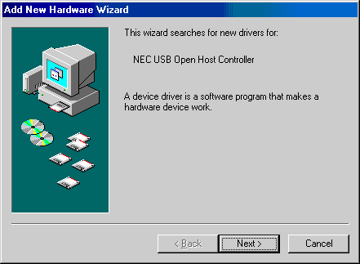

2 Select the option to search for the best driver for your device (Recommended) and click Next.

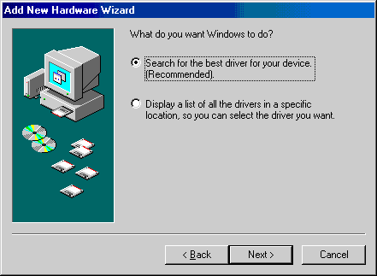

3 Uncheck all options and click Next.

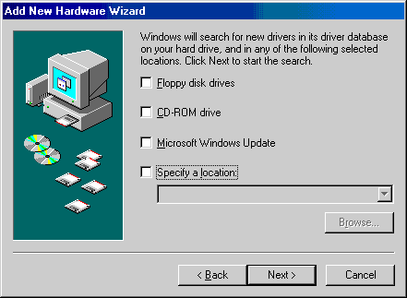

4 Select the option to install the updated driver (Recommended) and click Next.

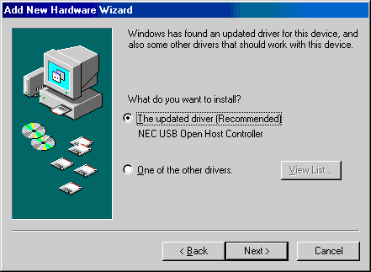

5 You may see a message that Windows is searching for the driver.
Click Next.

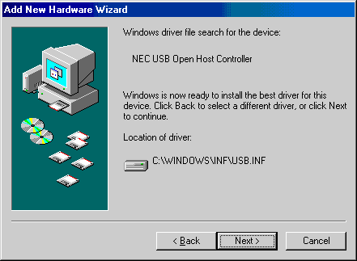

6 When you see the following prompt, insert your Windows 98 CD-ROM in your CD-ROM drive and click OK.

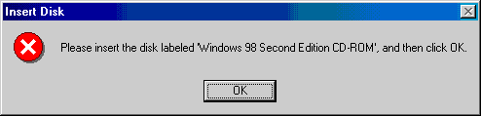

7 Type the drive letter for your CD-ROM drive in the Copy files from box as shown below and click OK.

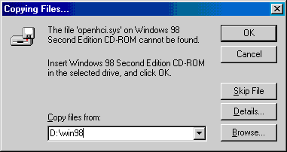

Note: If you have copied the driver files onto your hard drive and know where they are located, you can browse to that folder instead of inserting the Windows 98 CD. Also, your CD-ROM may not necessarily be “D”.

8 Click Finish to continue.

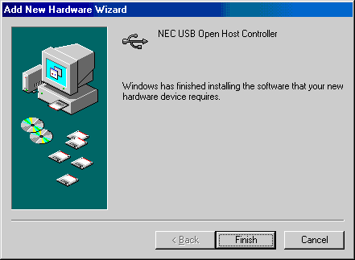

9 At this point, the driver for the first OHCI (USB 1.1) controller is installed.
To install the driver for the second OHCI controller, repeat steps 1 through 9.
10 The Add New Hardware Wizard will start again and attempt to install the EHCI USB 2.0 drivers. Click Next.

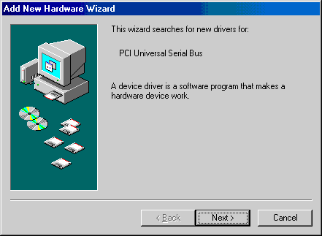

11 Select the option to search for the best driver for your device (Recommended) and click Next.

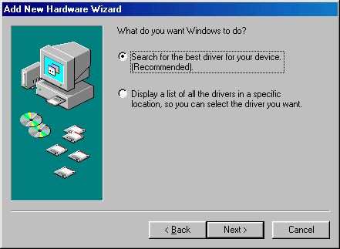

12 De-select all checkboxes and select the CD-ROM drive option, insert the USB 2.0 Device CD-ROM, and click Next.

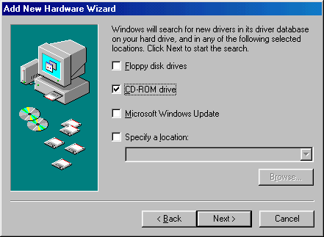

13 Windows will show you the location of the driver. Click Next.

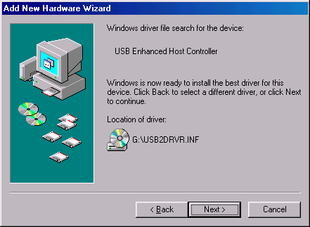

14 When Windows has finished copying files, click Finish.

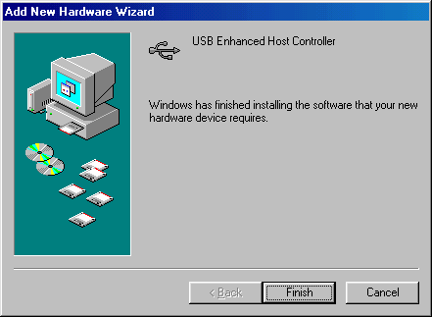

Verifying Driver Installation for Windows 98 SE

Use these instructions to verify successful driver installation on your system.

1 To verify that the driver is installed; right-click on the My Computer desktop icon, select Properties, click the Device Manager tab, and then click on the “+” (plus) sign next to Universal Serial Bus controllers to expand the list.

