Driver Installation for Windows ME

Driver Installation Guide Format

New Driver Installation for Windows ME: Use these instructions if you have just installed an Adaptec USB 2.0 card into your system. Remember that the first time you start your system after installing a card, it may take longer due to the fact that the operating system is locating and installing drivers for the card.

Verifying Driver Installation for Windows ME: Use these instructions to verify successful driver installation on your system.

New Driver Installation for Windows ME

After installing the USB 2.0 adapter, install the appropriate driver for Windows ME as described in this section.

Note: It may take longer than usual for your system to start after installing a new card because the operating system is locating and installing the new drivers.

During the operating system startup, the adapter will be detected and Windows will load embedded USB 1.1 and IEEE 1394 drivers.

- When the Add New Hardware Wizard appears, (if the CD is not inserted; please insert the CD), select Automatic search for a better driver (Recommended) and click Next.

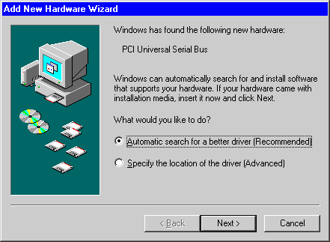

- After the driver is copied, click Finish.

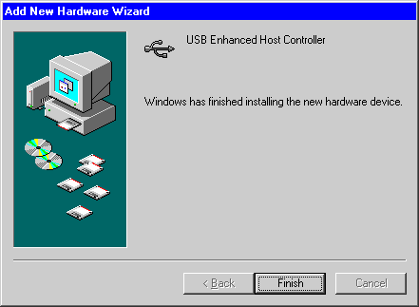

Verifying Driver Installation for Windows ME

Use these instructions to verify successful driver installation on your system.

- To verify that the driver is installed; right-click on the My Computer desktop icon, select Properties, click the Device Manager tab, and then click on the “+” (plus) sign next to Universal Serial Bus controllers to expand the list.

