Driver Installation for Windows 2000/XP

Driver Installation Guide Format

New Driver Installation for Windows 2000/XP: Use these instructions if you have just installed an Adaptec USB 2.0 card into your system. Remember that the first time you start your system after installing a card, it may take longer due to the fact that the operating system is locating and installing drivers for the card.

Verifying Driver Installation for Windows 2000/XP: Use these instructions to verify successful driver installation on your system.

New Driver Installation for Windows 2000/XP

Note: You must be logged on as Administrator or have administrator privileges to install the USB 2.0 device adapter on Windows 2000/XP.

During the operating system startup, the controller will be detected and Windows will load embedded USB 1.1 and IEEE 1394 drivers.

Note: It may take longer than usual for your system to start because the operating system is locating the new drivers

- When the Found New Hardware Wizard appears, click Next.

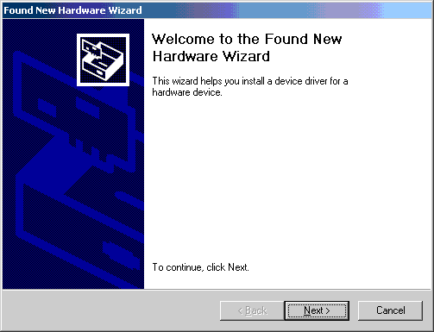

- When the Install Hardware Device Drivers window appears, select search for a suitable driver for my device (Recommended) and click Next.

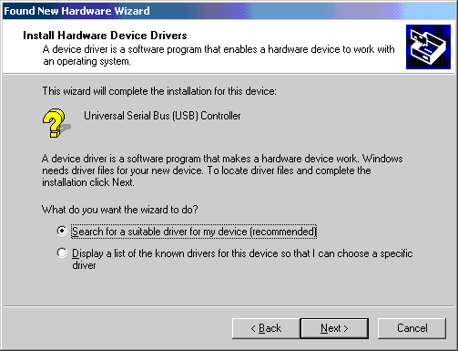

- The Locate Driver Files window will appear, uncheck all options except CD-ROM drives, (if the CD is not inserted; please insert the CD), and click Next.

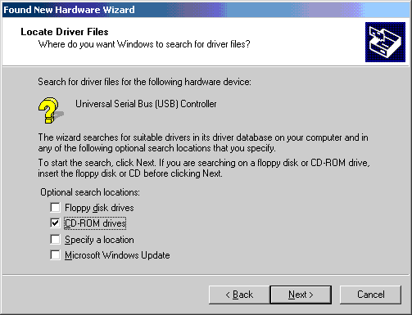

- Windows will report that it has found a driver for a Universal Serial Bus (USB) Controller. Click Next to continue.

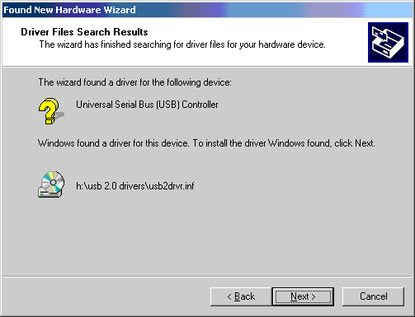

- When Windows is finished copying drivers, click Finish.

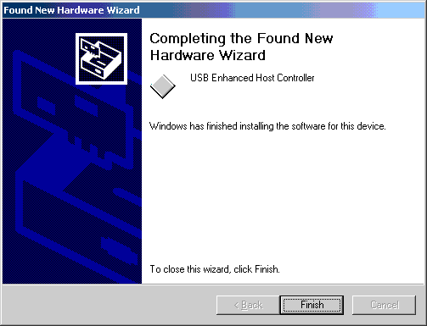

Verifying Driver Installation for Windows 2000/XP

Use these instructions to verify successful driver installation on your system.

- To verify that the driver is installed; right-click on the My Computer desktop icon, select Properties, click the Hardware tab, and then click Device Manager.

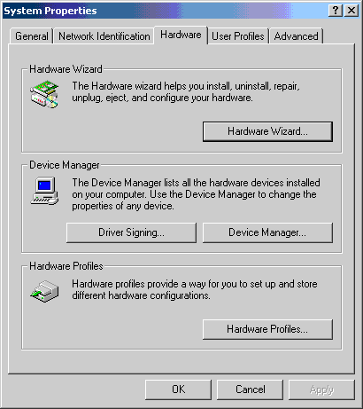

- Then click on the “+” (plus) sign next to Universal Serial Bus controllers to expand the list.

