- Start VCOM and Click “Search” to search the Printer in the intranet.

- Select the Decice No.

- Click “Configure” and input the Account: admin and the password: systme
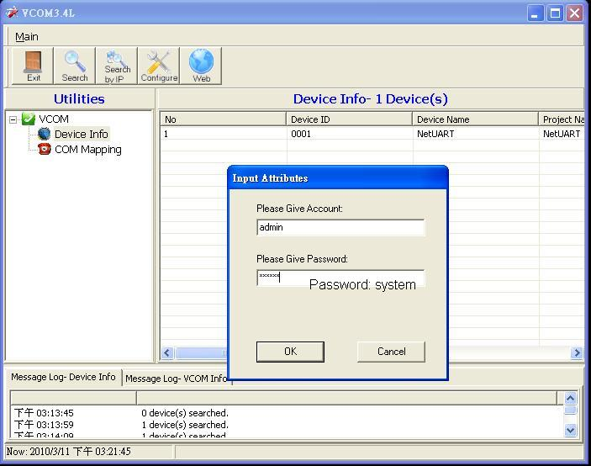
- Setup the suitable TCP/IP
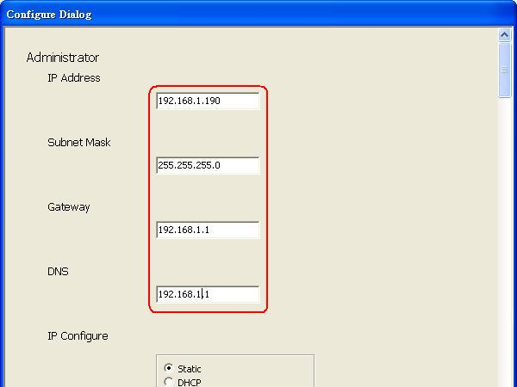
- Select the UART Baudrate = 19200
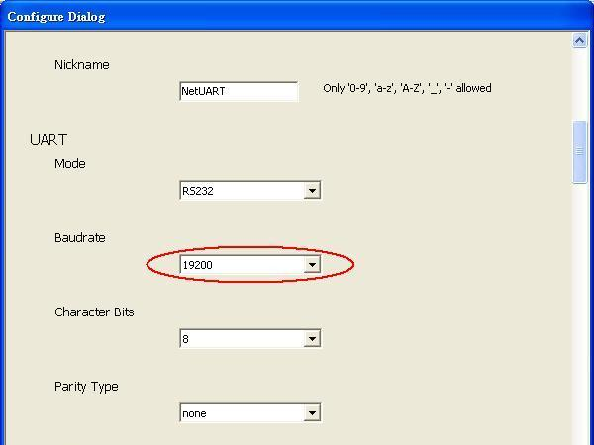
- Set the Data Port Number = 9100
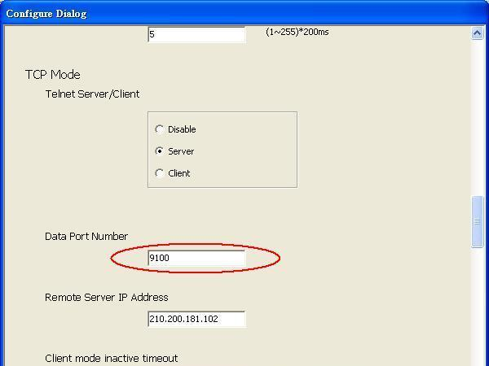
- Click OK to finish setting.
