Note: After upgrade, all the settings will restore to factory default, you can back up the settings first.
Step 1 Download the correct firmware according to the hardware version (Refer to How to look over the hardware version on a TP-Link device? to find the hardware version) from http://www.tp-link.com. If you still not sure which firmware you should use, please contact your local dealer or technical support.
Step 2 Log into the Router by typing http://192.168.1.1 (It is the default IP address if you haven’t change it) in the address bar of the browser (such as Internet Explorer, Chrome, Firefox or Safari). The User Name and Password are both admin in lower case unless you have changed it.
Step 3 Click System Tools > Firmware Upgrade on the left side, click Browse button to choose the firmware (.bin file) you have downloaded before.
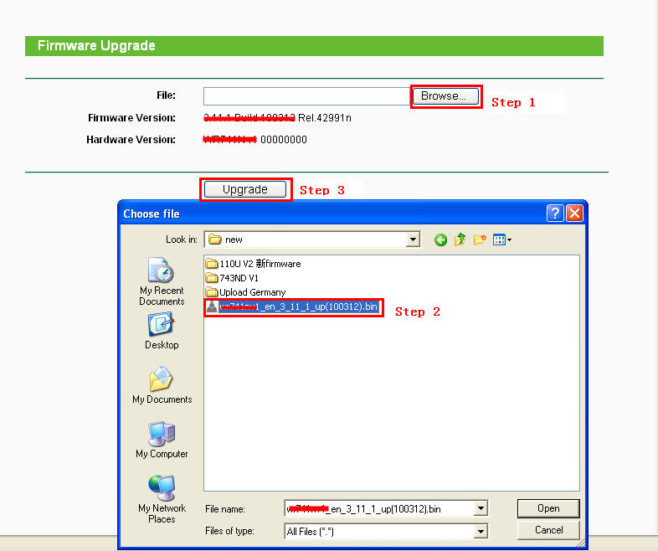
Step 3 Click Upgrade button, wait for the router to reboot.
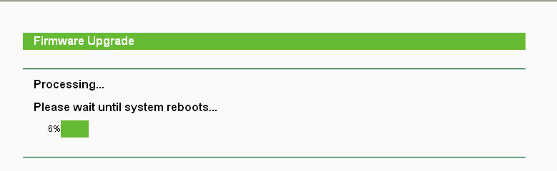
Caution: You should keep power applied during the entire upgrade process. Loss of power during the upgrade could cause DAMAGE the router and void your warranty.
Step 5 After the upgrade process is finished, you can restore the settings you have saved before.

