VP-EYE

Quick Operation Guide

Version 4.1
Table of Contents
USING VP-EYE A-1
Installation A-1
System requirements A-1
How to install software A-1
Getting started A-2
Application Panel settings A-2
Managing video data A-2
Monitoring a view (Video Monitor) A-3
Recording a Video E-Mail (Video E-Mail) A-4
Playing with your camera (Video Games) A-6
Gophers A-6
Black Jack A-7
Fishing A-7
Making a photo album (Photo EZ) A-8
Sending a greeting card (Photo Greeting Cards) A-9
Having fun with your photos (Photo Special Effects) A-10
Digital Movie Producer A-11
Appendix A-12

USING VP-EYE

Installation
This software package contains many applications for capturing and processing your videos and photos.

System requirements
- Pentium compatible processor, 200MHz
- USB port and USB camera or Video capture board and composite video camera
- Compatible for Windows98SE/ME/2000/XP
- 640×480 high color display
- 200MB available hard disk space
- 16× CD-ROM drive
- Windows compatible sound system with speaker and microphone
- Microsoft MAPI compliant email server
- Microsoft NetMeeting version 3.0
Copyright @ 2002 Meta Media, Inc. All rights reserved.

How to install software
Simply put the provided software CD into your CD drive. The setup software will automatically start, prompting you through the steps to install the video and photo software. You may enter the selection for the destination folder, the Start menu, Programs group and other setup options. The setup process will copy the applications to the destination folder. Note if Windows auto-run feature has been turned off on your computer, you will need to start the Setup.exe application on the software CD.

Getting started
All applications can be started from the Application Panel. The Application Panel can be started by clicking on the VP-EYE icon or by using the Start menu. If you are using the Start menu, select Programs followed by VP-EYE. Once the Application Panel appears, there are ten applications to select from:
1. | Video Monitor | 6. | Photo Special Effects
2. | Video E-Mail | 7. | Photo EZ
3. | Video Games | 8. | NetMeeting
4. | Digital Movie Producer | .
5. | Photo Greeting Cards
*Your CD may not have some of the above programs due to the version of software package

Application Panel settings
Click Settings button to access the Application Panel settings. Use the Settings dialog to change the video driver, language, sound, start menu and auto-run options.
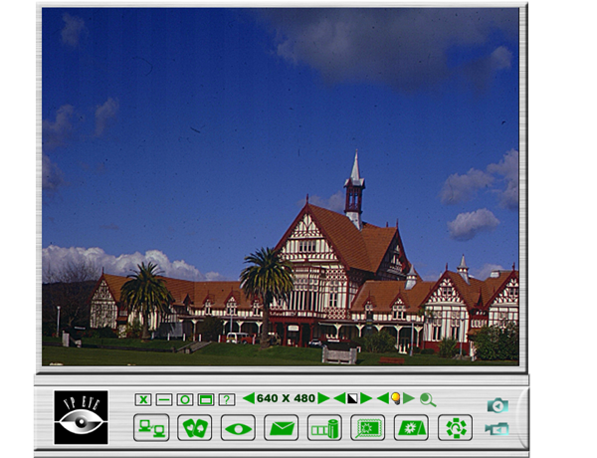

Monitoring a view (Video Monitor 2.0)
The Video Monitor can be used in many ways, such as video monitoring, recording and playback.

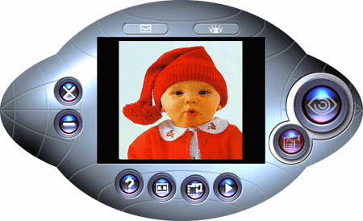
- Close– close the Video Monitor
- Message indicator – show whether you have new messages
- Security indicator – show whether security mode is working
- Minimize– minimize the Video Monitor window to an icon on the toolbar
- On top/Not on top– force Video Monitor always on top of the desktop or not.
- Setting– change the video monitor settings (General, Timer, Security, Message, Alarm)
- Playback– retrieve captured image data
- Help– explain how to use Video Player
- Message– start recording a video message
- Security– enter into security mode

Recording a Video (Video E-Mail)
The Video E-Mail is your digital recorder. Set the video size and start recording. Amazingly simple, you will wonder how you ever lived without it. You may record and save the video to a file or better yet, email it to a friend.
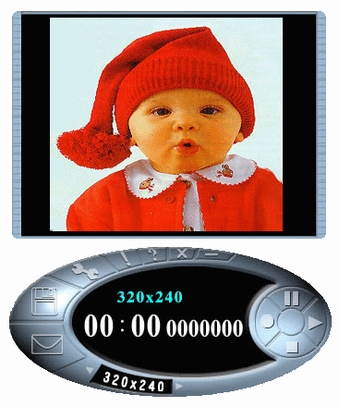
- Size– set video size
- Play– play current captured video
- Pause– pause current video, press play to resume
- Stop– stop playing video or cutting process.
- Record– start recording captured video
- Save– save video in the file
- Email– send compressed video to email
- Setting– set options for video source, recording time limit and compression
Well, this is very important! First, we really like compressed files, right? Compressed files take up less room and are easy to copy and email. The problem is you have to decompress your video when you want to view it.
“No problem! I compressed it, thus I can decompress it!”
Yes, you are correct! The problem is, can your friends decompress your video. Imagine you email your favorite video to a friend. You know he/she will really like your video. Later, you find out your friend deleted the file because they thought it was corrupted. So, what was the problem? Simple, your friend did not have the right decompression software.
Therefore, you may attach the player program mmvem.exe while sending the e-mail. This program decompresses the video and audio data, shows the video on your screen. It is easy to download the player from our web site if someone can not open the VEM file created by Video E-Mail program.

Playing with your camera (Video Games)
Do you like video games? Gophers, Black Jack, and Fishing are three popular
games included in this software package. All three work with your camera.
- Important: For best results playing any of these games, move the camera to a position where you can easily move your hands in front of the camera. Before the game logo appears, the camera will be calibrated. During the calibration, it is important not to move the camera. After proper calibration, the camera will be more capable of detecting your hand movements.

Gophers
Requires a camera to play. Object of the game is to hit the gophers. Beware of snakes.
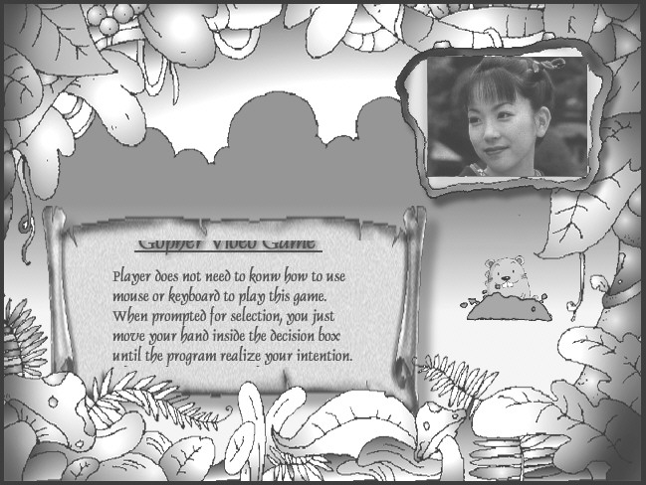

Black Jack
Requires a camera to play. Object of the game is to get 21 or less. Be careful, you have to have more points than the dealer to win. Same rules as Las Vegas 21.
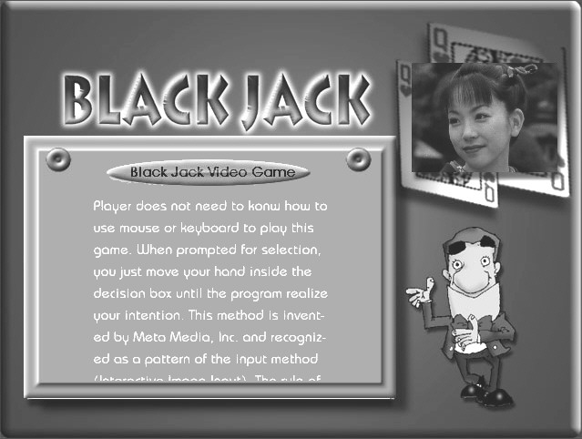

Fishing
Requires a camera and a mouse to play. Object of the game is to find matching photo cards. Use the camera to make your own photo cards, then send your game to a friend.
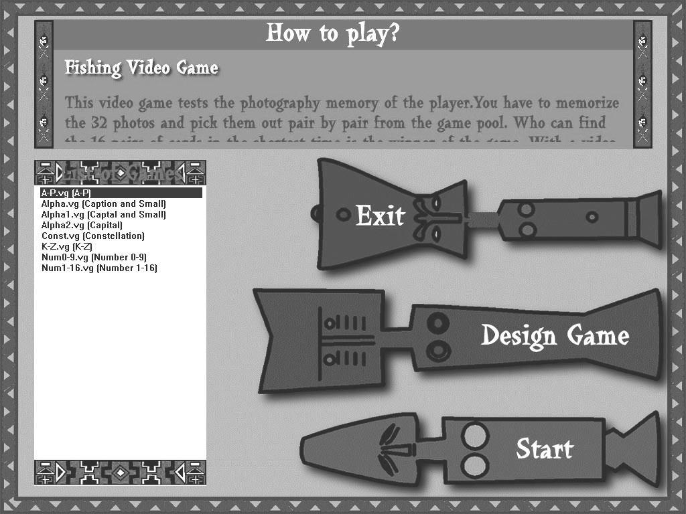

Making a photo album (Photo EZ)
Use Photo EZ to create one or more photo albums. Each photo can include additional information like date, author, place and other comments. Looking for a certain photo in all your albums? Search will look for all photos matching your search criteria. In addition, you can apply basic and special effects to your photos.

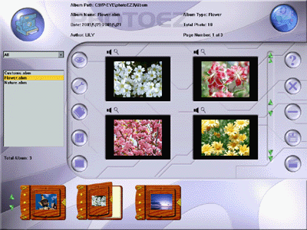

Sending a greeting card (Photo Greeting Cards)
Use Photo Greeting Cards to create electronic cards. Photo Greeting Cards has 20 categories containing over 100 different cards. Give it a try! Select a card, add some text, add your voice then make some final changes. There you have it, … an electronic card! Next, send it to your family or a friend.
Select a category then select a card.
- Photo– add a photo, maybe a snapshot of you
- Record– add background music or record your voice
- Flip– flip your photo side to side
- Scale scroll bar – adjust the size of your photo
- Opacity scroll bar – adjust the background of your photo
- Save– save your card to a file
- Print– print your card on paper
- Email– send your card to a friend
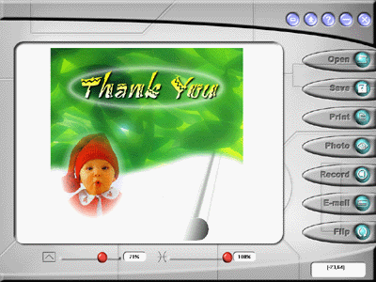

Having fun with your photos (Photo Special Effects)
Use Photo Special Effects to add special effects to your photos. Photo Special Effects has more than 50 different special effects. The effects are separated into color manipulation, transformation and blurring categories. It is fun, easy and fast to add special effects to your favorite photos. Give it a try!
- Open– open a photo image file.
- Undo– remove the last applied special effect
- Redo– reapply the last removed special effect
- Reset– reset the image to the original photo
- Save– save the result to a file
- Close – close Photo Special Effects
- Capture – capture a photo from the camera
- Special Effect– add special effects to the photo.
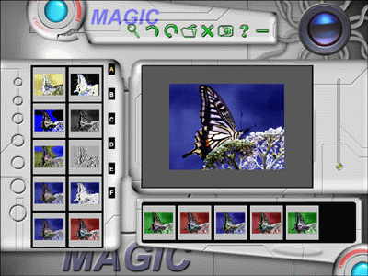
- Digital Movie Producer
It is a powerful and easy-to-use program for editing and converting video data. The user interface is simple. It may convert the photos acquired by digital camera into a video file. You may also add photo in the video stream or put two video streams into one. It allows you to add music and record the sound into the video file. Anyone can enjoy the fun of making video file by a few steps of this program!
- Open–open an existing video file.
- Save–save the result into a file.
- Play–play the result of video file.
- Select–select the input source of camera.
- Acquire–download the photos from the PC amera.
- Convert–convert the photo and audio data into video stream.
- Record sound–record the sound from the microphone or line-in device.
- Add sound–open a sound file and add it into the video stream.
- Clear–clear the selected photos.
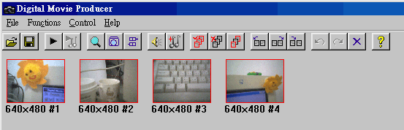

Appendix
Need more information? Looking for our latest products? Check our web site. At our web site, you can get the latest news and versions for our products. To log onto our web site, you will need a serial number and password. Both your serial number and password can be found in the Readme.txt file.
Web Site: http://www.mmedia.com.tw
Was the information you were looking for found on our web page? Want to talk to us about this software? Send us email. Tell us what you like. What you do not like. Interesting ways you use this software. What you like to see in future releases. We would like hearing from you.
E-mail: support@mmedia.com.tw
When sending email, please clearly detail your problem. We will return your email as soon as we can. We sincerely hope you enjoy this software. Thanks!

